

Travis Vanos

Group 3

GISC9301-D3

**ArcGIS Applications**



Mrs. Janet Finlay

Professor – GISC9301 December 10, 2015  
Niagara College GISC9301-D3  
135 Taylor Road  
Niagara-on-the-lake, ON  
L0S 1J0

Dear Mrs. Janet Finlay  
 RE: Submission: GISC9301-D3

Please accept this letter as our formal submission of Assignment three: GISC9301-D3: ArcGIS Applications for Travis Vanos. The works were completed with ESRI’s ArcMap and ArcCatalog software. The purpose of this assignment is to successfully gain the required knowledge for bringing the concepts and methodologies learned in the introductory ArcGIS together in a hydrology contamination report. The following sections will be fulfilling the deliverables as outlined in the GISC9301-D3. The requirements have been met along with the required database of Niagara Wineries collected in the GISC9303 - GIS Database & Data Warehouse Concepts course. The following procedures to be covered include, but are not limited to:

* Undertake a spatial analysis of Niagara Wineries, using ArcGIS
* Undertake required geoprocessing tasks to conduct hydrology contamination analysis
* Projecting the data and plotting a final map for presentation

Following the assignment procedures, please find the required material attached. Should you have any questions regarding the enclosed documents, please contact Travis Vanos at your convenience at [travis.vanos@gmail.com](mailto:travis.vanos@gmail.com). We eagerly await your comments and suggestions.  
  
Sincerely,

Travis Vanos   
 GIS/GM Candidate, Niagara College  
 T. V.

Enclosures: TVanos-GISC9301-D3.docx

VanosTGISC9301-D3.gdb

# Abstract

The purpose of this report is to outline the findings for the hydrology contamination affecting different systems surrounding Niagara region’s vineyards. The following encompasses the data collected in the field for geographic datasets for a variety of Niagara’s wine producers. Additional layers have been added from municipal data sources for roads, rivers and municipal boundaries. The results concluded that a total impact area of 61063 km2 can run off and contaminate any one of the given river systems.

Data has been collected for the vineyards in GISC9303 - GIS Database & Data Warehouse Concepts course for Latitude and Longitude as well as UTM Northing and UTM Easting. Wineries were classified under what type of wine they produced and the buffer was added accordingly to the different grape type. The intercepted buffers will leave us with areas that will require special attention whether economic or environmental reasons.

Table of Contents

Table of Contents

1.1 Abstract i

List of Figures iii

1.2 Introduction 1

1.3 Background 2

1.4 Project Goals 3

1.5 Methodology 5

1.5.1 Objectives 5

1.5.2 Database Creation 6

1.5.2 Adding a Base Map 7

1.5.3 Creating Feature Metadata 8

1.5.4 Creating Features in a Geodatabase 9

1.5.5 Buffer Analysis 10

1.6 Findings 12

1.6.1 Winery Buffer Analysis 12

1.6.2 Hydrology Buffer Analysis 13

1.6.3 Overlay Buffer Analysis 14

1.7 Conclusion 15

1.8 Appendix A 17

## List of Figures

Figure 1 Study Area of Hydrology Contamination 4

Figure 2 MS Access relational information 6

Figure 3 Joined Table Properties 6

Figure 4 Display X,Y data from tblWineryLocations 7

Figure 5 Define Projection 7

Figure 6 Metadata for .TIFF image 8

Figure 7 Geodatabade in Arc Catalog 9

Figure 8 Example of Converting Coordinate System in ArcToolbox 9

Figure 9 Wineries by Production Type 10

Figure 10 Merging of Winery Buffers 10

Figure 11Buffer of Hydrology Layer 11

Figure 12 Intercept of Buffers for affected areas 11

Figure 13 Result of intercept of Wineries Buffer and Hydrology Impact Area 12

Figure 14 Maximum Impact Area of All Wineries 13

Figure 15 Hydrology Contamination Buffer 14

Figure 16 Overlaid Area of Contamination 14

Figure 17 IMPACT ANALYSIS OF WINERY PRODUCTION ON HYDROLOGY IN NIAGARA PENNINSULA 16

Figure 18 CONTAMINATION AREA OF SELECTED WINERIES IN NIAGARA PENNINSULA 17

Figure 19 HYDROLOGY AREA OF INFLUENCE IN NIAGARA PENNINSULA 18

Figure 20 OVERLAY ANALYSIS OF AFFECTED HYDROLOGY FEATURES 19

# Introduction

Concerned with the water contamination of river and streams, a spatial analysis was needed to perform an examination of the area of which selected wineries have a potential impact and to present the findings in the report. A total of (12) different wineries were examined and assessed for a complete geographical and informational profile. Individual wineries have an impact radius of ground water each could potentially have around the region depending on their grape type they produce. These being rose, red and white wines.

Using ArcGIS, (4) maps were produced to demonstrate the results of the winery buffers, hydrology buffers, and the overlay analysis. A usable visual representation was needed to outline the potential of contamination. The result will be an insight of how wineries impact its surrounding area so that potential groundwater contamination could be controlled.

# 1.3 Background

The members of Equilibrium Consulting Ltd. have competed the required analysis for the hydrology contamination and consolidated the results in this report.

The raw and collected data has been overlaid atop of panchromatic imagery from 2006 (10cm) by the Municipality of Niagara. The spatial reference system is UTM NAD 83, 17N, estimated to the nearest centimeter from the digital aerial photography. Winery information and locational information had been collected into a Microsoft Access Database File (.mdb) containing all winery and product information. The required locational information had then been extrapolated from the required tables to complete the required procedures. Winery information in the tblWinery table had then been joined to the winery Location table (tblWineryLocation) to provide all relevant information including the Winery ID, Name, notes, founding year, wine production type, etc. Following provided objectives and procedures the data has been collected and processed accordingly for final quantitative results and interpretations. Other features for use in this project had been provided by the city of Hamilton and the municipalities in the Niagara area. Requiring a common projection, all data-sets and feature classes were then assigned the proper UTM NAD 83, 17N projection and coordinate system.

# 1.4 Project Goal

This report aims to identify the wineries which are causing contamination of local hydrology features based on a buffer analysis of selected wineries and their respective wine production type. The data will help to identify areas which cause the largest area of potential contamination based on an overlay buffer analysis to indicate the larger contributors.

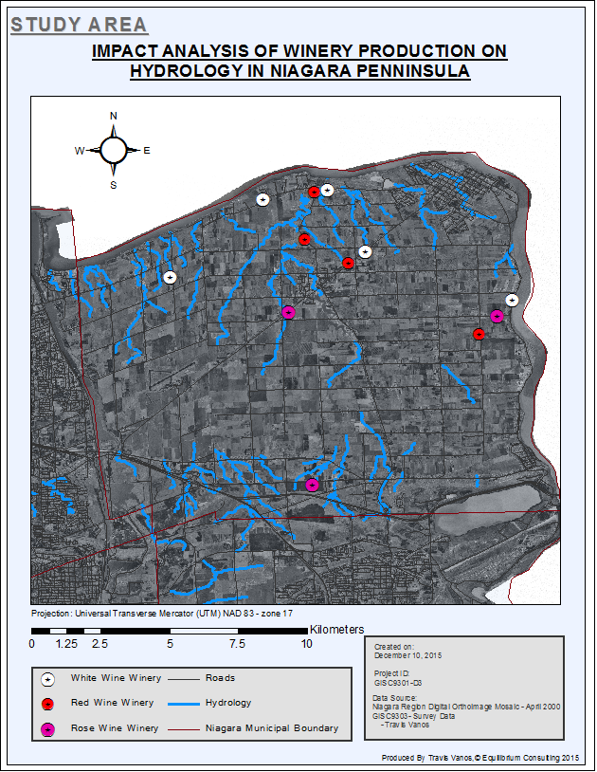

Figure 1 Study Area of Hydrology Contamination

# 1.5 Methodology

## 1.5.1 Objectives

As outlined in the project deliverables, the following (10) objectives have been completed in ESRI’s ArcGIS Suite. The objectives below have been summarized as major tasks in each objective.

|  |  |
| --- | --- |
| ***Objective #1*** | Create a layer of DOI raster Imagery (Mr. SID Compressed) |
| ***Objective #2*** | Import of wineries’ relational data into ArcGIS. (.mdb) |
| ***Objective #3*** | Create metadata for the newly created personal geodatabase using ***ArcCatalog***. |
| ***Objective #4*** | Relate and/or join applicable tables in ***ArcCatalog*** |
| ***Objective #5*** | Import the National Topographic Database Series |
| ***Objective #6*** | Create a Niagara-On-The-Lake Municipal Boundary Layer within the geodatabase |
| ***Objective #7*** | Create a layer within the geodatabase for the streams of Niagara-On-The-Lake using the Hydrology data |
| ***Objective #8*** | Undertake a buffering of winery features by wine type produced |
| ***Objective #9*** | Undertake a buffering of hydrology features |
| ***Objective #10*** | Undertake an overlay analysis for the buffers derived in objectives 8 and 9 |

## 1.5.2 Database Creation

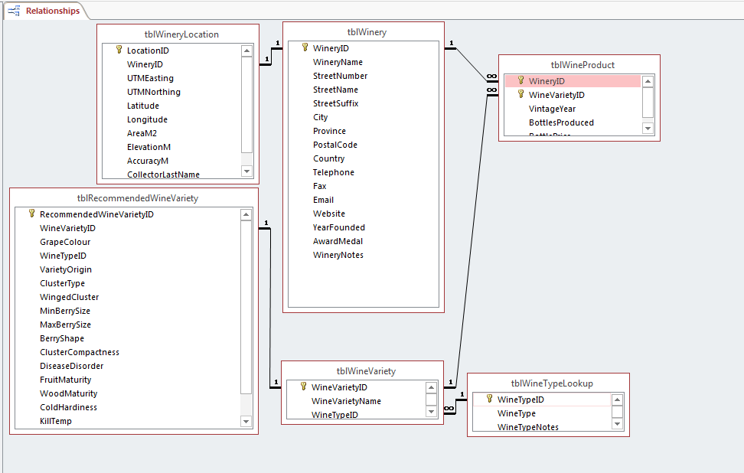In the field, winery geographical information had been collected by various sections of students and consolidated for use. Winery information and locational information had also been collected through a variety of other resources, i.e Winery website information and Google earth, to merge into a Microsoft Access Database File (.mdb).

Figure 2 MS Access relational information

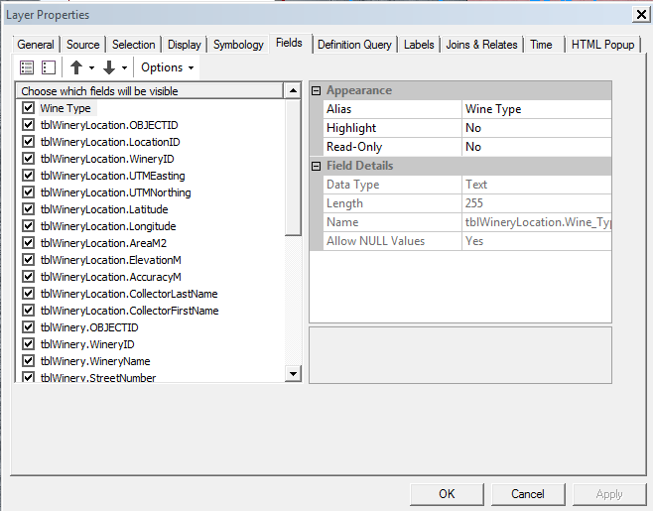Appropriate fields were then added to provide the needed functionality of the hydrology contamination buffer areas. Using ESRI’s ArcCatalog, the required tables were then imported and converted for use in a made geodadabase for later processing. Only the required locational information had then been extrapolated from the required tables to complete the required procedures. All relevant information including the Winery ID, Name, notes, founding year, wine production type, etc.

Figure 3 Joined Table Properties

The tables then needed to be joined on a common attribute (Foreign and Primary Key of tblWineryLocations). The result is then a table with all fields in both the tblWinery and tblWineryLocations.

When the tables have been joined and all required geographical data is present the X,Y data can then be shown by extracting a Latitude/Longitude or UTM Easting/Northing co-ordinates from the field data.

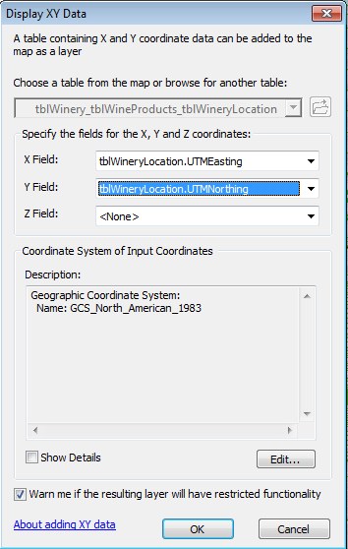

Figure 4 Display X,Y data from tblWineryLocations

## 1.5.2 Adding a Base Map

A base map of the Niagara region is needed to overlay the applicable features. It is required to project the Niagara Region Orthoscopic .tiff image in UTM Zone 17N, NAD 1983. Firstly a projection was defined using the define projection tool in ArcToolbox.

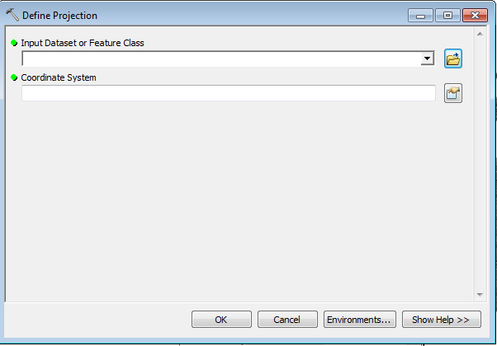

Figure 5 Define Projection

Using the provided Niagara Region Orthoscopic .tiff image a base map is produced as seen in Figure 5

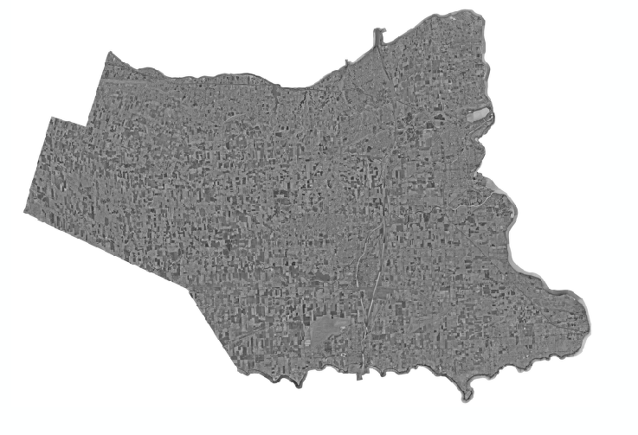

Figure 5: Base map of the Hamilton/Niagara Region

## 1.5.3 Creating Feature Metadata

With new features imported from various sources metadata was added to provide readability for future use as well as credit to applicable parties as seen in *Figure 6*.   
  
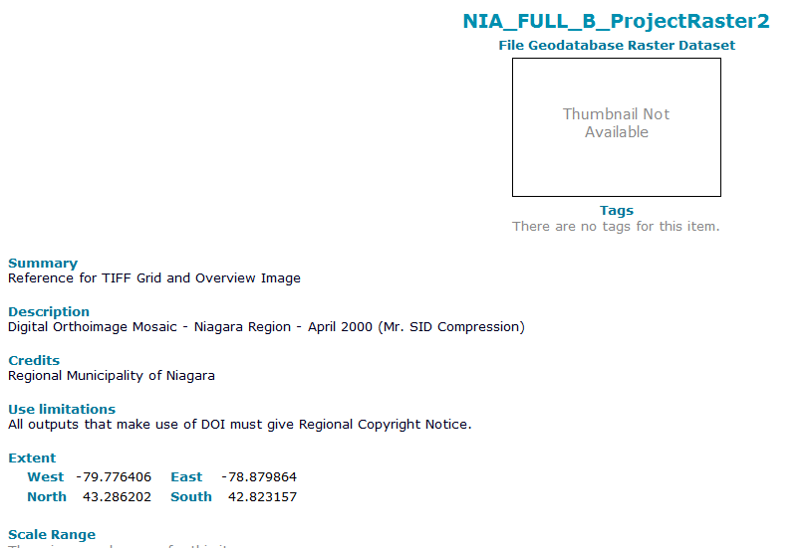

Figure 6 Metadata for .TIFF image

## 1.5.4 Creating Features in a Geodatabase

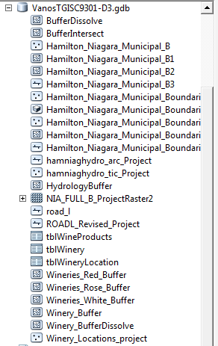

Figure 7 Geodatabade in Arc Catalog

Housing the data-sets would require a geodatabase. A Geodatabase (.gdb) was created to store all layers of feature classes and tables applicable to this study. Files including road and infrastructure features were available with incorrect or no projection/ co-ordinate system defined. After adding these data-sets to the geo-database the python scripts (tools) under the Projection and Transformation were used to alter the features accordingly. Using the tools available in ArcToolbox, a co-ordinate system was defined and the feature classes were projected using the UTM NAD 83, 17N projection. After the assignment and projections had been carried out, housing the data-sets would require a geodatabase and was created to store all layers of feature classes and tables.

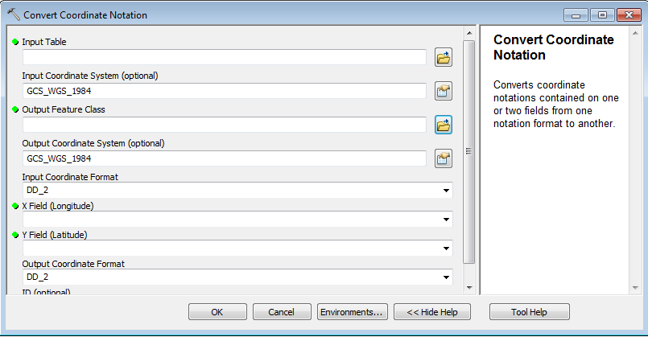

Figure 8 Example of Converting Coordinate System in ArcToolbox

Objectives #5 through to objective #8 were imported in the geodatabase using the tools listed above. In addition, metadata was added for all features.

## 1.5.5 Buffer Analysis

The data set was given and imported into Arcmap from the ArcCatalog. The winery data was then separated by wine type they produced to provide the applicable buffer. The winery data had been split into three new point features for white wine producers, red wine producers and rose producers

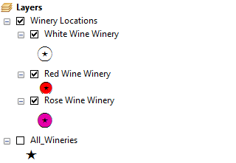

Figure 9 Wineries by Production Type

After the buffer has been added to the layer based on the criteria (white wine- 500 meters, red wine 1.5 km and rose, 2.5 km) the buffers were then merged to give us the total impact area of all wineries.

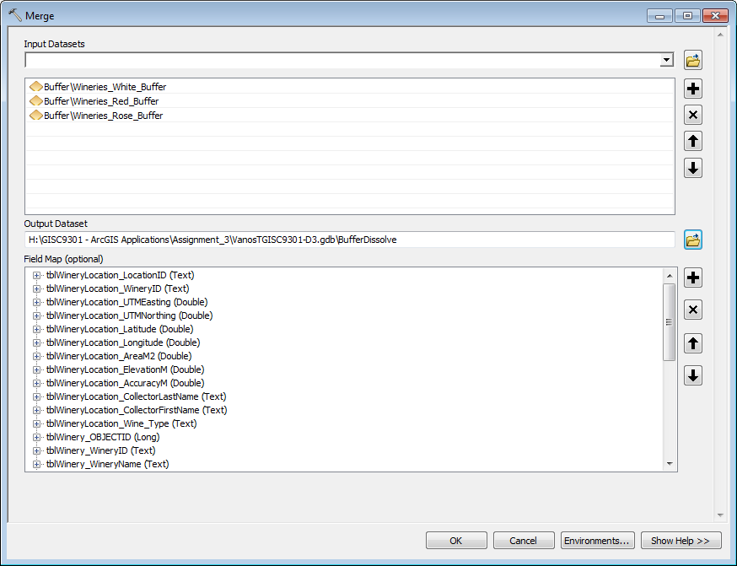

Figure 10 Merging of Winery Buffers

The same method had been applied to the hydrology polyline feature to give the ground water impact area.

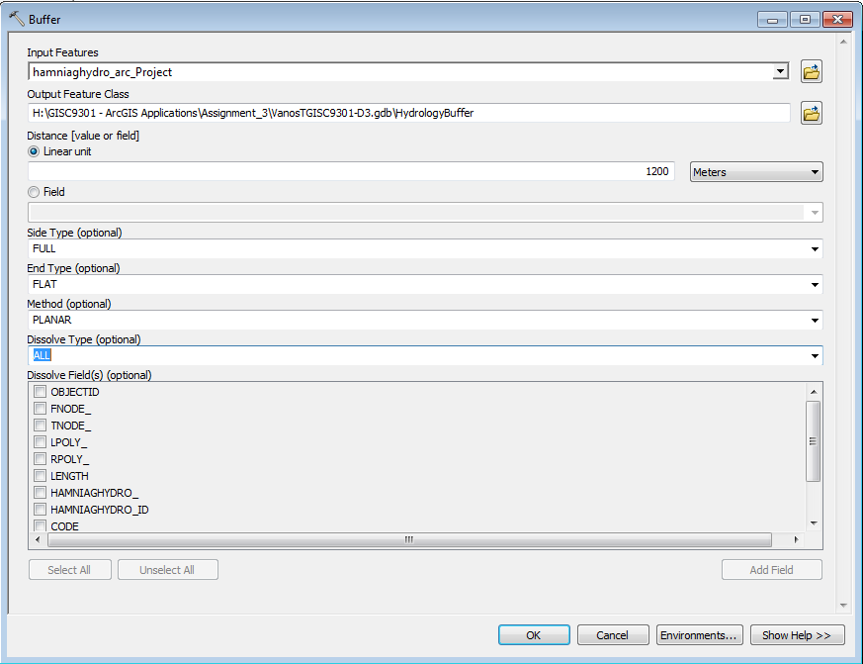

Figure 11Buffer of Hydrology Layer

As a final step of the analysis, an intercept of the two buffers, merged winery buffers and hydrology buffer, were then run through the intercept tool to get the final affected area.

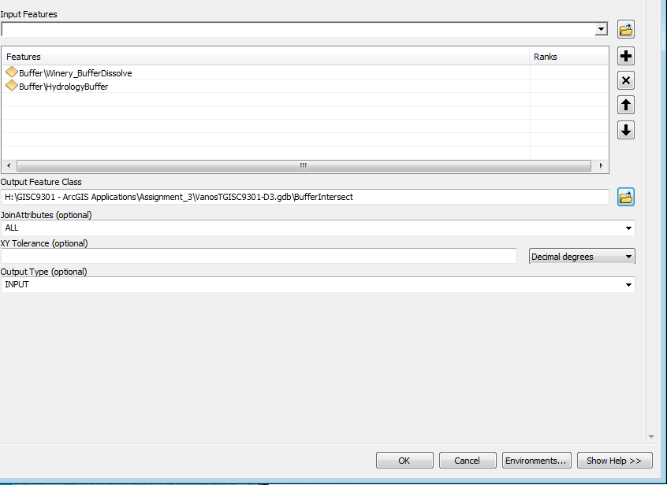

Figure 12 Intercept of Buffers for affected areas

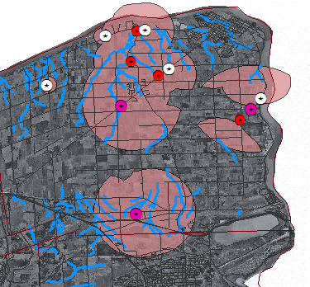

Figure 13 Result of intercept of Wineries Buffer and Hydrology Impact Area

# 1.6 Findings

The findings which are presented in the final map layouts located within the Appendix are a result of a series of buffer and overlay analysis of the study area. The findings show different impact areas and areas of interest in the affected regions. The completed (10) objectives aimed to identify the wineries which produced the highest risk of contamination to the areas hydrological features which are outlined in detail below.

## 1.6.1 Winery Buffer Analysis

Based on the wine type produced by the wineries show our final maximum impact area of 72712.068 km2 for all wineries. The buffer demonstrates the potential for chemicals; fertilizers used to create the various wine types, that can run-off and affect ground water and/or river systems. The chemicals all have a different impact distance and are based off of average traveling distance. The distance for rose wine had been recorded at a maximum of 2.5 kilometers range, red wine at 1.5km and white wine at 500 m. The figure below demonstrates the ranges found.

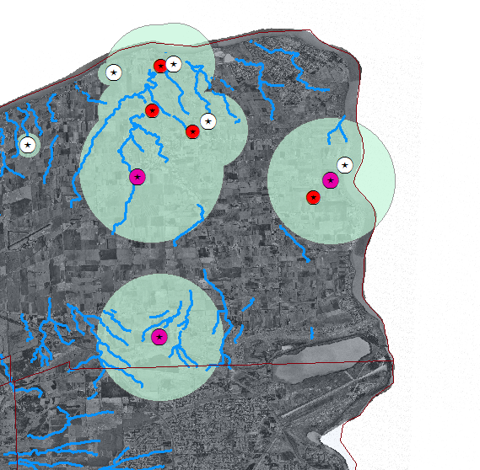

Figure 14 Maximum Impact Area of All Wineries

As shown above wineries which grow rose wines have the largest area of impact and thus can contaminate the largest area. The contamination encloses much of the region which is all the more need for proper precautions to be developed. Without development for safe hazardous waste removal, the run-off of these chemicals can have serious and lasting effects on the water systems located in the Niagara region.

## 1.6.2 Hydrology Buffer Analysis

Hydrology features located around the Niagara region can be impacted by contaminants ground water 1200m away from any point of the river system. The buffer demonstrates the maximum distance from the stream centerline that contaminants can reach the feature, as shown in 15. Coving most of the Niagara Peninsula, the contamination penetration is vast with a total contamination area of 2900928.1 km2 and affected by many of the wineries.

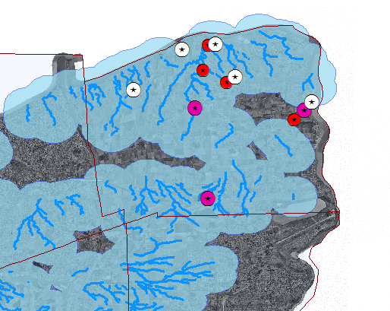

Figure 15 Hydrology Contamination Buffer

## 1.6.3 Overlay Buffer Analysis

The overlay analysis demonstrates the area that is likely to be contaminated due to the overlap of the maximum winery contamination area and maximum hydrology contamination. Figure 16 presents the overlay of buffers showing the areas at risk to contamination. Showing all (12) of the wineries there is a total of 61063 km2 of hydrology that can be affected by the wineries.

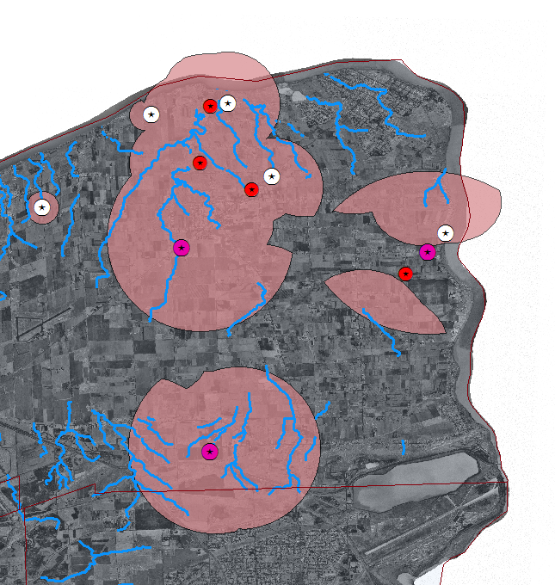

Figure 16 Overlaid Area of Contamination

The area that has potential for contamination is expansive, covering the majority of the Northern of the Niagara Peninsula. Changing regulations needs to occur to prevent contamination from increasing further. Proper research can be conducted to reverse the agents already in the streams and proper precautions need to be taken.

# 1.7 Conclusion

The expansive extent of the potential run-off area has been presented with the area of impact outlined in figure 16. The results concluded that a total impact area of 61063 km2 can run off and contaminate any one of the given river systems within the Niagara Peninsula. With a growing concern for the water contamination of river and streams, a spatial analysis has been presented for the wineries looked at in this study. Precautions and regulations should be in effect to minimize the risk for further hydrology risk.

Demonstrating safe and effective water quality practices has multiple benefits that should be recognized so that wineries accept the need for change. A stress for sustainability should be a factor in choosing any new vineyard locations and chemicals for the health of the entire hydrology system. Practicing responsible business has a lasting effect on the ecosystem should be a factor in consumer’s choice for wines in the area.

# Appendix A



Figure 17 IMPACT ANALYSIS OF WINERY PRODUCTION ON HYDROLOGY IN NIAGARA PENNINSULA

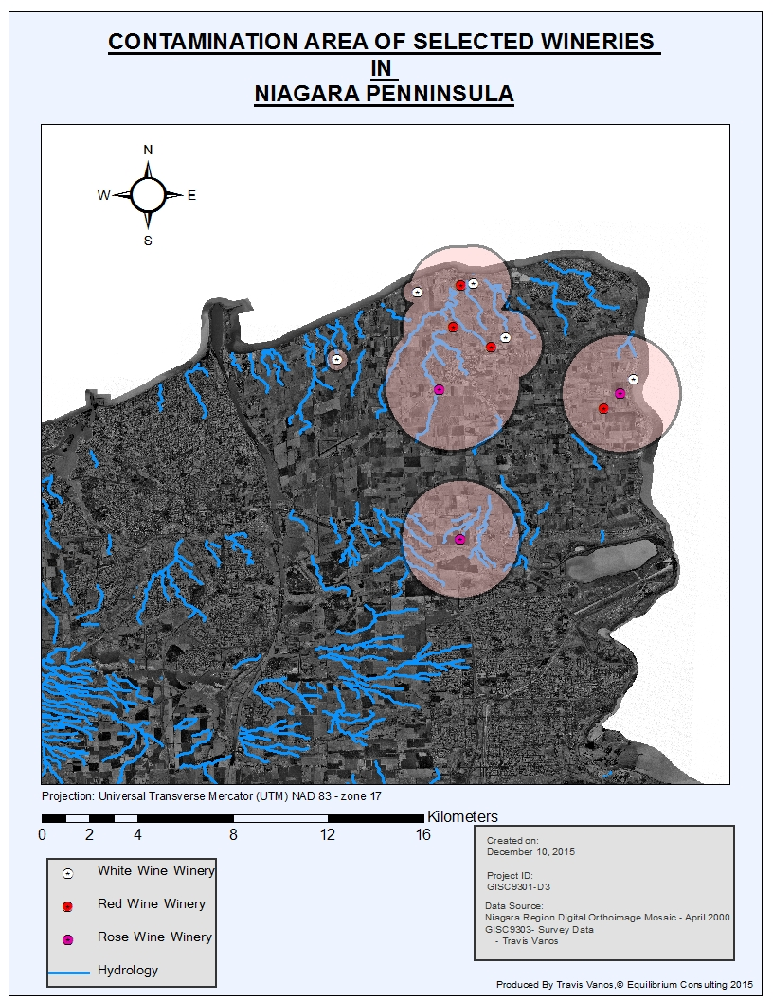

Figure 18 CONTAMINATION AREA OF SELECTED WINERIES IN NIAGARA PENNINSULA

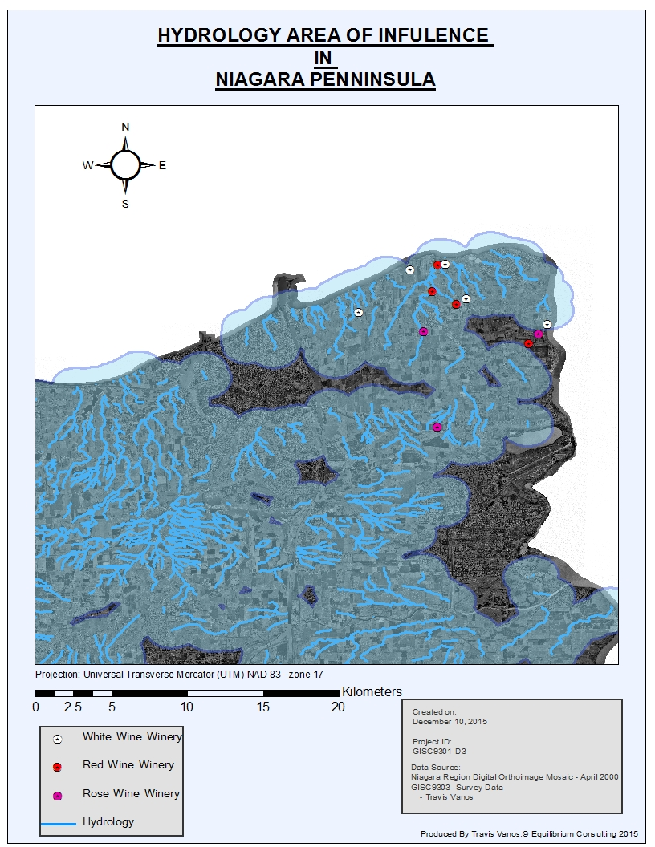

Figure 19 HYDROLOGY AREA OF INFLUENCE IN NIAGARA PENNINSULA

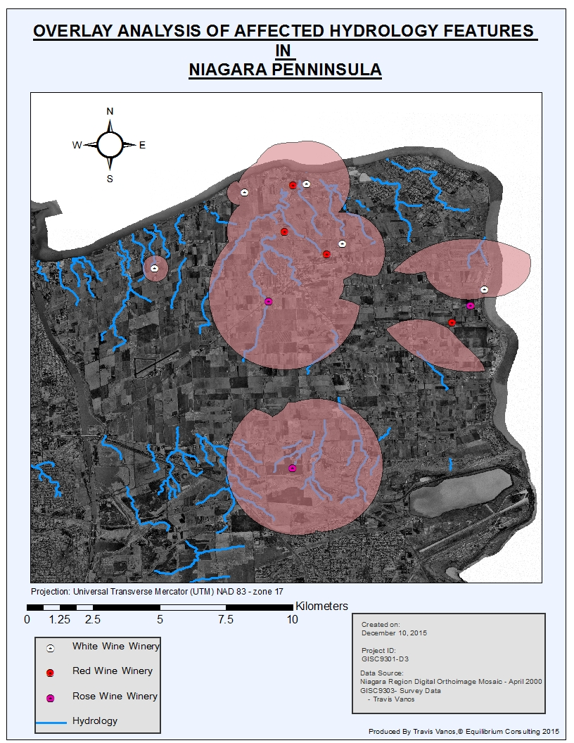

Figure 20 OVERLAY ANALYSIS OF AFFECTED HYDROLOGY FEATURES